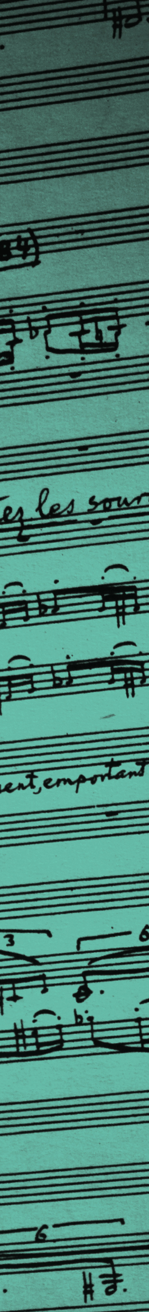
George Enescu (1881 – 1955)

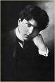
George Enescu is widely regarded as the greatest Romanian composer in history. He was also a great concert violinist, a fascinating teacher (Yehudi Menuhin was his most famous student), a conductor of depth and subtlety, an esteemed musicologist and a tireless organizer who took on spectacular tasks such as forming a Philharmonic Orchestra, founding the Romanian National Opera in Bucharest and the Union of Composers in Romania.

Enescu was born in the village of Liveni, Romania, and showed musical talent from early in his childhood. A child prodigy, he created his first musical composition at the age of five. Shortly thereafter, his father presented him to the professor and composer Eduard Caudella. At the age of seven, he entered the Vienna Conservatory, where he studied violin with Joseph Hellmesberger Jr., Robert Fuchs, Sigismond Bachrich, and graduated before his 13th birthday, earning the silver medal. In his Viennese concerts young Enescu played works by Brahms, Sarasate and Mendelssohn. In 1895 he went to Paris to continue his studies. He studied violin with Martin Marsick, harmony with André Gédalge, and composition with Jules Massenet and Gabriel Fauré.

One can divide Enescu's oeuvre in two large stages: initially a time for introspection and collection, and then for harvesting the results. The composer starts the series of his works with two remarkably mature pieces of chamber music, the 2nd Sonata for piano and violin and the Octet for strings. Enescu is not yet 18 years old when he completes the sonata and has not reached his 19th birthday when he delivers the octet. Especially the latter is a counterpoint chef d'oeuvre displaying an extraordinary architecture.

Many of Enescu's works were influenced by Romanian folk music, his most popular compositions being the two Romanian Rhapsodies (1901–1902), the opera Oedipe (1936), and the suites for orchestra. He also wrote five symphonies (two of them unfinished), a symphonic poem Vox maris, and a lot of chamber music (three sonatas for violin and piano, two for cello and piano, a piano trio, quartets with and without piano, an octet for strings, a piano quintet, a chamber symphony for twelve solo instruments).

In 1923 he made his debut as a conductor in a concert given by the Philadelphia Orchestra in New York City. In 1935, he conducted the Orchestre Symphonique de Paris and Yehudi Menuhin in Mozart's Violin Concerto No.3 in G major. He also conducted the New York Philharmonic between 1937 and 1938 and was considered as Arturo Toscanini’s successor.

From a very early age Enescu was highly appreciated and became close to the Royal House of Romania. In 1939 he married Maria Rosetti (Princess Cantacuzino through her first marriage).

He lived in France and in Romania, but after the World War II and the Soviet occupation of Romania, he remained in Paris.

He was an excellent violin teacher. Christian Ferras, Ivry Gitlis, Arthur Grumiaux and Ida Haendel were among his pupils. He promoted contemporary Romanian music internationally and at home, playing works by Constantin Silvestri, Dinu Lipatti, Mihail Jora, Ionel Perlea and Marţian Negrea, amongst others.

Enescu died in Paris in 1955 and is buried in the Père Lachaise Cemetery.

Today, Bucharest has a museum in his memory; likewise, the Symphony Orchestra of Bucharest, as well as the George Enescu Festival, are named and held in his honour. Through the Enescu Society, the Romanian Cultural Institute aims to make Enescu’s outstanding music better known to wider audiences in the UK.

